|  |
| --- |
|  |



**29 March 2013** **The Weekly Bulletin of Rotary Club of Kathmandu Mid-Town** **Bc-29.3/012-13**

**District : 3292 Web: www.rotarymidtown.org.np Club Id : 26776**

**MARCH IS LITERACY MONTH**

Teach children the value of life, and that they should respect others, no matter what sex or caste they belong to. If you can change their way of thinking, and introduce them to a better way of life, you will be doing them and the entire community a great service.

Friday, 8 March:

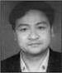

Guest Speaker, Dr Jeevan L Amatya, a veterinary doctor by profession provided a very

useful notes on uses and effects/benefits from health point of views, of various spices and

dried fruits such as mustard seeds, cloves, garlic, asafoetida, turmeric, cinnamon, cumin,

nutmeg, and coriander.

Friday, 15 March:

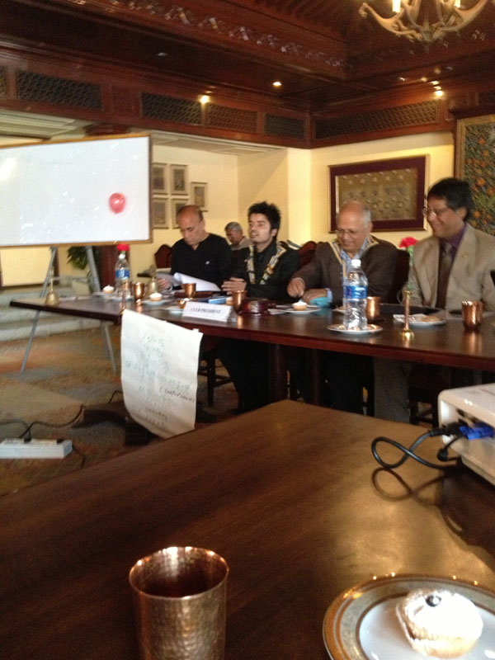

Rtr Kishore Acharya, President of Rotaract Club of Kathmandu Mid-Town,

presented the activities of the Rtr club with great enthusiasm and

confidence. The club has been able to make this year a special with

various new initiations like a campaign of eye screening of more than

10,000 school children, provision of prosthetic arms to 60 needy people,

joint International skype meeting, token of love being presented to RIP

and being able to create international project where the club facilitate

and encourage other clubs from different district to participate.

The club has been recognized by MDIO for Extensive Free Eye Camp

and by RI for being one of the three winners in Interact Video

Competition. Behind all this success story, he emphasized, that there was the hand of *guruma* Rtn. Lekha, various Rotarians, Parent club, Rotaract members and guests.

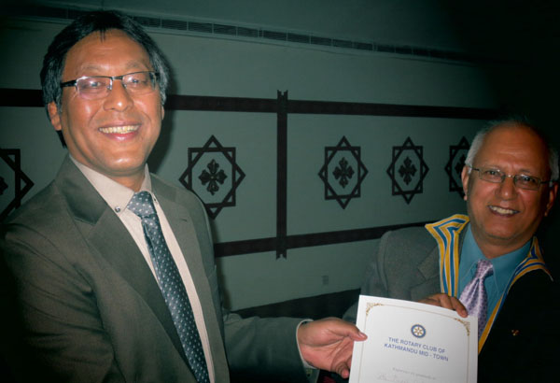

Friday, 22 March (Dinner meeting):

The regular breakfast meeting of the Club was re-scheduled as

dinner meeting on the same day evening at the regular venue, i.e.,

Hotel Annapurna, Durbarmarg with a view of giving farewell to

Rtn. Buddha, Club Secretary 2012-13, who was scheduled to

return to India on 25 March after completing his assignment tenure

in Surya Nepal. Rtn Buddha talked about his professional

experiences in Nepal and appreciated cooperation he received from

all corners. He shared his happiness for being involved in the Club

and working together with Mid-Towners in whatever little way and

possible times during his stay in Nepal. He also provided a brief presentation on various slides of his involvement in Rotary and Rotaract club activities. His experience on Bipasyana was one of the most valuable and it did inspire him to plan for establishment of a Bipashyana center in Shillong India. He expressed his happiness to be a part of RC Kathmandu Mid-Town.

# Weekly Meetings and Programs :

|  |  |  |
| --- | --- | --- |
| Date | Program/Speaker | Program/Topics of Presentation |
| 29 March 2013 | Rtn. Mahesh Bhakta Shrestha | Photo Journey to Everest Base Camp |
|  |  |  |

Friday, 29 March:

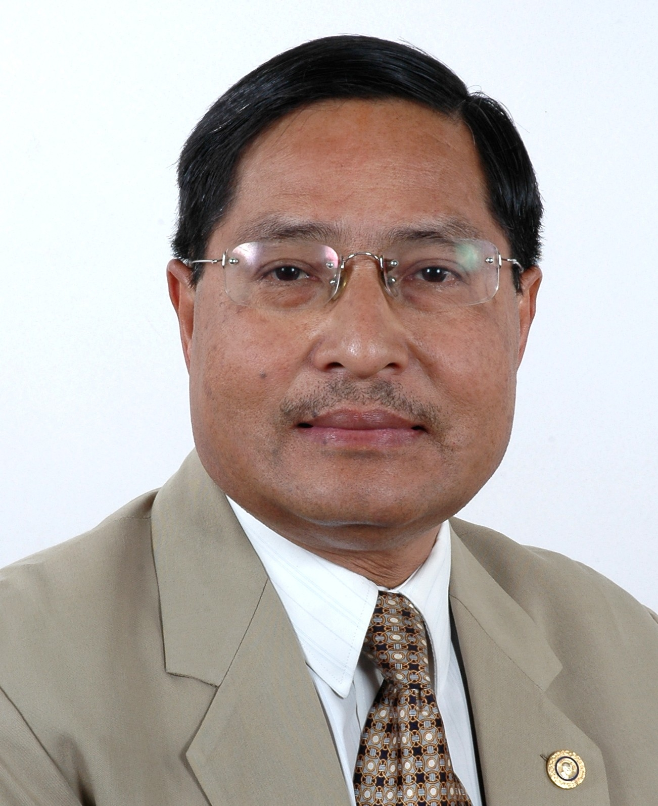

Guest Speaker, Rtn MB Shrestha, will be providing a presentation on photo journey

to Everest Base Camp. Rtn MB is PP of Rotary Club of Kopundol, Lalitpur who served

as the first District Secretary of RID 3292 in RY 2008-09. He has traveled to 54 districts

of Nepal including base camps of Mount Kanchanjungha, Mt Everest, Mt Manaslu, Mt

Annapurna in the pursuit of tourism planning, photographic exploration etc. He has keen

interest in photography and has been doing photography for over 40 years.

**District Conference:**

The 5th District Conference was held as scheduled on 16th-18th March 2013 in Kathmandu, venue – Soaltee Crown Plaza Hotel. The theme of the 5th District Conference was “Samarpan” - ” Dedication”. The theme was symbolized by the Peepal Leaf: Nepalese tradition, norms and values teaches us to offer as much as we do to other living kinds. It symbolizes dedication, purity and humanity.

[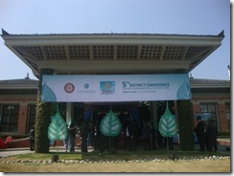](http://technetnepal.net/cfs-file.ashx/__key/CommunityServer.Blogs.Components.WeblogFiles/rotary/DSC03047_5F00_2DF80FB4.jpg)[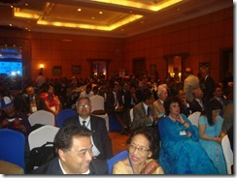](http://technetnepal.net/cfs-file.ashx/__key/CommunityServer.Blogs.Components.WeblogFiles/rotary/DSC03063_5F00_57229F40.jpg)

District Conference Committee Chair Rtn. Anand Tuladhar giving his Welcome speech - "District Conference is the most significant annual event of the District. A time to regenerate a sense of belongingness to a larger fraternity and to inspire members to re-dedicate themselves to the Rotary cause and the Rotary way."

[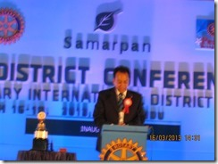](http://technetnepal.net/cfs-file.ashx/__key/CommunityServer.Blogs.Components.WeblogFiles/rotary/IMG_5F00_4117_5F00_3812849A.jpg)[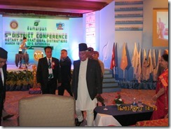](http://technetnepal.net/cfs-file.ashx/__key/CommunityServer.Blogs.Components.WeblogFiles/rotary/IMG_5F00_4114_5F00_1BB86F05.jpg)

The Conference was inaugurated by Chief Guest Rt. Hon'ble Paramanand Jha, Vice President of Nepal by lighting Panas.

Rotarians from 76 Clubs participated in the Conference. Altogether 8 Keynote Speakers – Dr Suresh Raj Sharma, PDG Tirtha Man Sakya, Ms Chadani Joshi, Mr Dawa Steven Sherpa, Dr Roop Jyoti, Dr Ram Kantha Makaju Shrestha, Mr Yuva Raj Ghimire and IPDG Basu Dev Golyan provided their presentations on varied subjects/topics – development, family values, community service, peace and development etc.

**Visiting Grande International Hospital, Dhapashi:**

**A group of Mid-Towners paid a visit to Grande International Hospital, Dhapashi on Friday morning, 22 March, as per the schedule;**

**Thanks to CP Roop Jyoti (Chairman, GIH) for organizing the visit and providing informations on Hospital operation, infrastructure, state of the art service equipment/facilities, services provided and service facilities being installed;**

**???**

.

Invitation of Rotaract Club of Kathmandu Mid-Town:

The Rotaracts of Kathmandu Mid –Town would be honored by your presence at a program of

**“Handing over of funds to support the acquiring of a vehicle for SGCP**“

Fund received through kind courtesy of Rotary Club of Landshut, Germany

**Chief Guest: He Excellency Frank Meyke (Ambassador of Federal Republic of Germany)**

Date: 5th April 2013, Time: 10.15 am Location: SGCP (Self Help Group of Cerebral Palsy, Dhapakhel

Rtr. Kishor Acharya, President (RAC Kathmandu Mid-Town)

**On Literacy:**

Education: Most of the time when we talk about Education, we think about school. We often view school in a traditional, formal sense. Many people believe that true learning can only take place in a formal classroom setting. Others feel education occurs in many different forms and environments. There may not be a definitive answer to the question of, ‘What is Education?’ However, we can start thinking about the purpose of education. Is it to educate youth to be responsible citizens? Is it to develop individuals, as well as society, in order to ensure a society’s economic success? Or is the purpose of education to simply focus on developing individual talents and intelligence? Perhaps it is the balance of all three that defines education? While our answers may differ, we can perhaps agree that education is a basic human right. When that right is granted growth and development, the society as a whole is more likely to improve in areas such as health, nutrition, general income and living standards and population fertility rates.

In 1990 UNESCO launched EFA, the movement to provide quality education for all children, youth, and adults by the year 2015. The unfortunate reality is that for many countries, larger issues precede improving the quality of education. How can we achieve the goals of EFA when numerous countries around the world are faced with challenges that seem far too impossible to overcome?

The answer lies in attempting to bridge some of the gaps that prevent developing nations to compete with developed nations. One example is that of providing greater access to technology and narrowing the ever widening digital divide. In many ways the most basic access to technology can serve as a valuable educational tool. Individuals who are not afforded this access are at a disadvantage when trying to grasp opportunities to make life better for themselves, their families, and their community.

Another issue that poses a barrier to widespread development is that of literacy. There still remains a rather larger percentage of illiterate youth and adults in many nations around the world. Economic difficulty and lack of education get in the way of decreasing illiteracy rates.

The gender gap in education points to the fact that females are still not afforded the same opportunities as males. In many parts of the world cultures see no value in educating females. Two of the eight Millennium Development Goals, achieving universal primary education and promoting gender equality, seek to close the gaps that exist in the education around the world. If we can make some advancement on achieving these goals, we can further the progress on the remaining six. Education is the foundation for the success of any given society. Numerous studies have shown the correlation between education and lower birth rates, lower infant mortality rates and fewer maternal deaths. Furthermore, a more educated population will also result in higher personal incomes as we all expand access to financial opportunities. In summary therefore, education does not only encourage personal development, it also offers the general growth of an entire community providing a place for people to interact, socialize, and unify their societies.

*Source: www.tigweb.org*

**Committee Chairpersons' Column:**

**???**

**Past Presidents' Column:**

**???**

Focus the energies of your clubs on the three priorities of the RI Strategic Plan: (a) to support

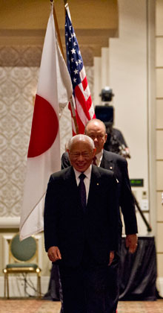

and strengthen clubs, (b) to focus and increase humanitarian service, (c) and to enhance

public image and awareness.

**RI President Sakuji Tanaka**

On Lighter Side :

Click here ⇩



A thought for the day:

***What have you done today for yourself,***

***for the family, for the community, for the nation and for the humanity ?***

Great quotes:

***Negative Thinkers focus on Problems***

***Positive thinkers focus on Solutions !***

Number game:

If 1 ÷ 3 = 0.333333333333….

1 ÷ ? = 0.555555555555….

NB: Send any informations/photos that may be of interest to the Club or Rotarians in general to

BC Editor: RR Shrestha email: rryesrr@gmail.com

## 29 Mar 2013 The Weekly Bulletin of Rotary Club of Kathmandu Mid-Town bc-29.3/012-13